**Fabric and Window Treatments**

**IDEC1045**

**Week 7 Hard Blinds and Shutters**

1. Replace the highlighted areas above.
2. Fill in the cells on the right in the table below.

## Week at a Glance

|  |  |
| --- | --- |
| **Week at a Glance** | |
| This week’s course learning outcomes (number and text) | **CLO02:** Evaluate fabric construction that includes weaves, yarns and durability for various window treatment needs.  **CLO03:** Explain fabric and drapery terminology, dye lot differences, pattern repeat railroading and common care codes for cleaning and maintaining materials.  **CLO04**: Outline current fabric trends including pattern, texture and styles as well as uses and benefits of linings to create quality window treatments for various uses  **CLO05:** Calculate both hard and soft treatments to custom order from a manufacturer or seamstress based on appropriate measurements to complete a window treatment order for a client. |
| This week’s unit learning outcomes (number and text) | **Unit 7:**  **7.1** Recognize hard window treatments and trends including blinds, shutters and shades  **7.2** Measure hard window treatments  **7.3** Describe various uses of blinds for sun and privacy protection  **7.4** Apply layering techniques for both soft and hard treatment combinations. |
|  | |
| This week’s problem | Previously we have talked about soft treatments and fabrics. This week we move on to hard treatments that are equally important in the window treatment industry. We will learn about the different kinds of hard treatments and how they can be used alone or in conjunction with soft treatments. The student will also learn how to measure for these treatments to custom order from a manufacturer and what information an installer needs to put them into a home. |
| How does this week’s problem fit into the course so far? | This week is the next step into learning about window treatments. Hard treatments are very popular in today’s décor and an important topic to understand. |
| List of topics and subtopics that will be covered to address this week’s problem | **Hard Window Treatments:**  **Blinds:** Wood, Vinyl, metal, roller, roman, pleated, mesh, sizing, measuring  **Shutters:** California, traditional, sliding panels, sizing, measuring  **Top treatments:** Cornice, lambrequin, Cantonniere  **Specialty windows:** Measuring unequal widths on a window**,**  French doors, window cranks, corner windows, bay windows. |
| If this is a hybrid course, what topics and activities will be covered in-class to support the online content? |  |
| How does problem fit into the remaining weeks of the course? | This week is a continuation of how to use various treatments in the home. Hard treatments can be used on their own or with the soft treatments learned in previous weeks. The student will need to know how to measure and calculate these in all future weeks, assignments, test and final project |
|  | |
| Graded Assessment? | Yes. Fill out the Evaluation section below.  No. |

Introduction

|  |  |
| --- | --- |
| **Introduction to Week** | |
| Introduction | Description of content for this week:   * Explain what the user will learn * Describe the problem the user will be able to solve by the end of week * Answer the question “What’s in it for me (the learner)?”   This week we will be focusing on hard window treatments like blinds and shutters. These hard treatments are very popular and can be a practical solution to many window needs today. We will look at the various options on the market, how to measure for the correct sizing and what styles of décor they suit.  Hard treatments are an ever growing option today and can be used on their own or in conjunction with soft treatments making them very versatile. |
| Learning Outcomes | Write out the week’s unit learning outcomes here (number and text).  **Text: Designing Interiors 2nd , pages 479 - 482**  **Unit 7:**  **7.1** Recognize hard window treatments and trends including blinds, shutters and shades  **7.2** Measure hard window treatments  **7.3** Describe various uses of blinds for sun and privacy protection  **7.4** Apply layering techniques for both soft and hard treatment combinations. |
| Other relevant announcements/ reminders | Insert notes on assignments and/or anything out of the ordinary.  Note: You can also add an image here for a front cover page look and feel.  Istock id: 184862328  C:\Users\Linda\Desktop\Documents\ONTARIO LEARN FABRIC\PHOTOS ISTOCK\184862328.jpg |

****************** Beginning of instructional content ************************

Hard Window Treatments

For the past number of years there has been a strong trend to use hard treatments on windows such as blinds and shutters. They usually operate with cords on the right or left of the window frame and increasingly today with remote control. Remote control now even can be programed to work from your tablet or cell phone! They are especially popular in condos and homes with two story windows. Overall hard window treatments provide an easy care, tailored look that suit most styles of décor.

Over the years the popularity of these treatments has improved the options available so that today there are hundreds of choices, colours, textures and style to choose from. They offer a great alternative to soft fabric treatments and can be used on their own or layered with soft treatments as well.

There is no one treatment that is suitable for every room or every home and this lesson will describe a range of options and uses.

Hard window treatments like soft, offer privacy, sun protection and insulation to a window or door. When selecting any kind of window treatment it is important to consider the needs of each room and what is best for that location. I have often seen some streets where every home has the same treatment showing from the street, however not every home functions the same way and so one kind of treatment will not be the best choice for all homes.

What you will learn this lesson will allow you to make a more knowledgeable selection of blinds and shutters for every room in a home to suit the needs of those using it.

## Blinds:

Hard blinds come in many styles and we will look at each individually to describe them.

Blinds can be purchased ready- made or custom. Like soft treatments the quality and fit will always be better with custom selections and the selection is vastly different between the two. Ready -made is often found at big box stores and can be suitable for short term use, however for a final treatment or long term use, custom treatments will be a less costly investment over time. Blinds in general are easy maintenance and can be cleaned with a soft cloth or vacuuming.

### Sizing

Hard treatments can be mounted with either inside mount (in window area only) or outside mount (outside the window and trim) or wall mount (above the trim from the top of the trim to the ceiling). You also need to consider the depth of the window in the room. Some windows are flush to the wall and others are recessed by about 2” or more. Older homes often have deeper recesses up to 12 or 18 inches. You need to determine if you have enough room to use an inside mount depending on the depth of the treatment blind slats or header needed to install the treatment.

### Measuring

Measuring windows for hard treatments is the same as soft treatments. You measure top, middle and bottom of the horizontal width measure and left, middle and right of vertical length measure. Always measure each window even if they appear to be the same size as small differences are common and will affect the treatment size. Measure as accurately as possible to the 1/8” of an inch. Make sure to use a metal sturdy tape measure.

**Inside mounts** use the narrowest measure on the width and the longest measure on the length. The narrowest measure would be used to order and deduct ¼” in total (1/8” on each side of the blind) from that width to allow the treatment to operate without touching the frame.

**NOTE:** some manufacturers deduct this amount automatically so check to make sure this number is not deducted already when you order.

**Tips to remember for inside mount:**

* Measure exact size in 3 places on width, top, middle and bottom of area inside the trim of the window
* Order lowest measurement of width so blind fits in smallest part of window)
* Measure exact size in 3 places on length, left, middle and right of area inside the trim of the window
* Record all measures on working graph paper drawing
* Order by longest measure of length
* Deduct ¼” total from width to allow ease of operation on blind (1/8” on each side will be deducted by manufacturer). State this deduction on order form.
* State what side you want to locate the operating cord (left or right)

**Outside mounts** use the widest measure on the width and the longest measure on the length. Add 1 ½ ” past the frame on each width side of the frame as some frames are not square and you want to make sure all the frame is covered by the treatment. Add 1 ½” below the frame to make sure the frame does not show. You can mount directly on the frame if the blind is not to be raised up and down and only opened by adjusting the slats.

**Tips to remember for outside mount:**

* Measure exact size in 3 places on width, top, middle and bottom including width of trim on each side
* Order widest measurement of width + add 1 ½” on **each** side past the trim
* Measure exact size in 3 places on length, left, middle and right including length of trim on top and bottom
* To mount the blind on the top frame, order by longest measure of length + 1 ½” past the trim on the **bottom**
* State what side you want to locate the operating cord (left or right)

**Wall mounts** above the frame, hang a minimum of 4” above the frame and to 1 ½” inches below the bottom frame. The amount above the frame depends on the length of the blind. Wall mount hanging allows to hang the blind as high as needed to allow for what is called **stack height.** It is the amount of wall space needed to allow the blind to open fully and be right off the window or if you want a more vertical look to the blind in the room.

**Tips to remember for Wall outside mount:**

* Measure exact size in 3 places on width, top, middle and bottom including width of trim on each side
* Order widest measurement of width + add 1 ½” on **each** side past the trim
* Measure exact size in 3 places on length, left, middle and right including length of trim on top and bottom
* To mount the blind above the frame on the wall add at least 4” above the frame or to the height you want the blind to hang from (between 4” above the trim to the ceiling) and add this height to the length.
* Order by longest measure of length + 1 ½” past the trim on the **bottom + the distance above the frame**
* State what side you want to locate the operating cord (left or right)

**General blind Measuring tips:**

* Draw the window on graph paper in ½” scale as your working copy and file for future reference.
* Measuring the wall spaces around the window are also a good idea for future reference as well. Some windows that are close to a corner need to show that spacing to allow certain treatments to be used.
* Be sure to always measure twice for accuracy.
* Windows that are an odd shape, 2 story or something you are not comfortable with, get an installer to check measure for you. The cost is worth it to be accurate and can save you expensive errors.
* When measuring in a home you should also note which side you would want the operating cord to be placed on.
* Many blinds can have multiple blinds on one headrail so that each section can operate independently on one window. For example if you have a living room window with 3 sections to it, you can have blinds made that fit each window size and have them all operate separately, giving the user the option of opening/ closing each section as desired.

This is an excellent website by Hunter Douglas about hard window treatments.

<https://www.hunterdouglas.ca/window-treatments>

### Wood and Vinyl

Wood and Vinyl blinds are also known as venetian blinds. Wood blinds come in different slat sizes. The most common is 2” depth or deeper. This is when you have to make sure you have enough recess in the window to accommodate this depth and still be able to operate the blind. Wood comes in stain finishes from light to dark as well as whites and in some cases can be custom coloured for an extra fee.

This kind of blind is very attractive in a window and can be opened or closed by the slats or raised up and down by cords. The blind slats are held together with cords or band attachments. These blinds can get very heavy to raise when used on Patio doors or large windows.

Istock id: 185072598

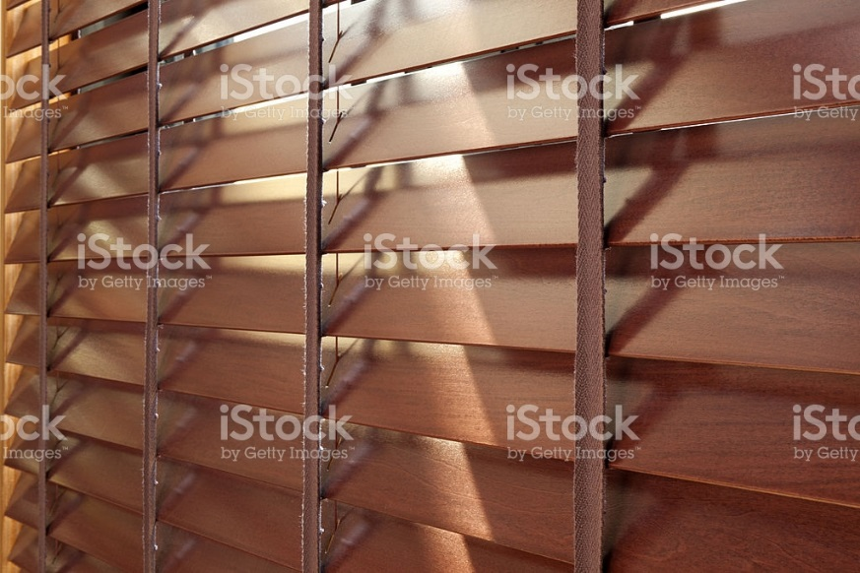

### Metal

Metal blinds are often the least expensive of all blinds and are very commonly found in ready-made. They can be custom made in a variety of colours, however I only order them in neutral whites or metallic. The metallic like gold, silver and copper are very attractive and modern looking and the whites are versatile when changing colours in a room. These blinds come in 1” called mini blinds and ½” called micro mini blinds. They can come wider now as well in 2” blinds and are offered in many finishes. Metal blinds are relatively inexpensive compared to some other kinds of blinds and are good great choices for budget conscious selections. They also provide a great deal of light when the slats are opened.

### Pleated (cellular)

Pleated blinds are small pleats that come in simple pleats or honeycomb style in various textures and colours. These blinds are also called cellular blinds. It is also possible to get a blackout lining installed, however all backs of blinds facing the exterior of the window usually are a neutral white or ivory backing in good quality makes.

Pleated blinds usually operate on cords, however some manufacturers also offer some cordless styles. Pleated blinds stack up very small and can be mounted to be almost invisible on a window when wanting a very open look in a room. These blinds are available in a regular operating style where the blind when down covers the entire window or in a “top/down” fashion when the blinds can be closed on the bottom and open on the top to any level desired. This top/down use is great to provide privacy on the bottom level while allowing light coming into the room from the top.

**NOTE:** Many master bathrooms today have large almost picture size windows and often in front of the tub. I use these blinds with the top/down style on those windows for privacy. Not one wants to be visible from the outside when climbing into the tub!

Available in horizontal up/down style or now vertical (left/right) operation, they are an excellent choice when the user wants a treatment to give privacy yet take up very little stacking when fully open. The blinds are made of various fabrics that can be easily spot cleaned and can be professionally cleaned by checking with dealers in your area if necessary.

Istock id: 182503209

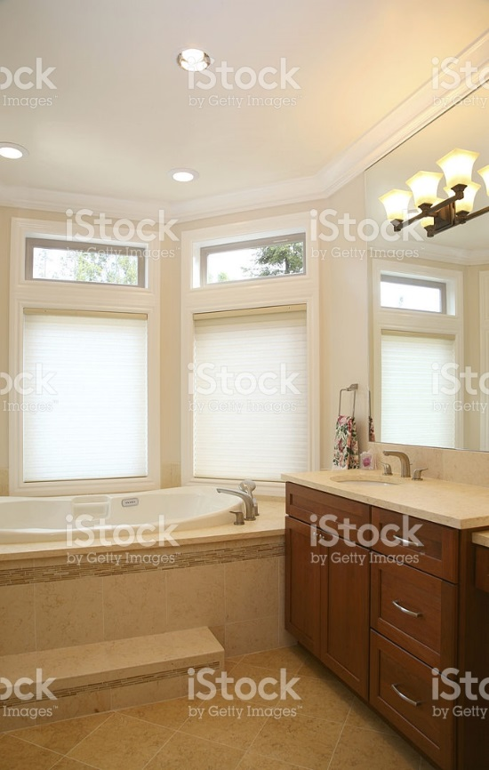

### Woven wood

Woven woods are very popular now as they provide a great amount of texture to a window. They can be used on their own and also look wonderful when used with a soft treatment like side panels. They can be roller (rolling down from a headrail) or roman style (fold down from a headrail) and come in many colours from light to dark. Some have fabric woven into them in patterns as well in custom orders. These can be readily found in ready-made in wood tones or neutral white. Most woven woods are not totally opaque and allow some light to enter at all times of the day or night but are a great choice for those who enjoy filtered light and privacy on the window.

Istock id:

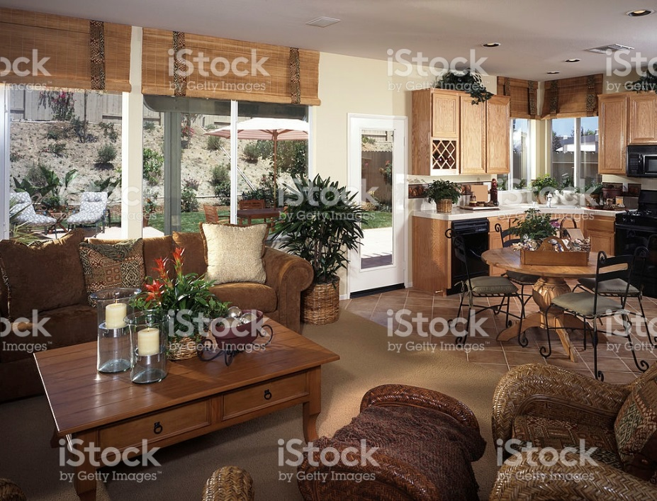

### Mesh

Mesh blinds are seen frequently in restaurants to block sunlight while still being able to view outside. They are a great contemporary and minimal look in homes offering a variety of colours, textures and levels of opaqueness. They usually operate with metal cords on one side of the blind and can be used on many sizes of windows for a modern and clean look.

**NOTE:** They have a tendency to skew to one side when placed on very wide windows and operated up and down frequently.

Istock id: 514229538



### Sheer

Sheer blinds can take the place of soft sheer drapery for a more modern look in a room. Some names for this style are known as silhouette that have a sheer and a fabric in the center that can open and close the blind so that you can have a sheer at some times of the day and then close to have privacy as needed. Usually found in a neutral colour so as to not change the colour of furniture and walls in a room, they can be a modern and interesting take on a sheer treatment.

**NOTE:** You need a minimum of 2” recess for inside mounts due to the size of the header used for this treatment.

## Shutters:

Shutters are extremely popular in today’s décor. They come in a traditional style that has narrow slats and the most popular Plantation (California) style that has wide slats from about 2-5” deep. Offered in a variety of neutrals and wood tones, they can also be custom painted to a room colour for an additional charge. The only caution with these wonderful shutters is to remember that they are like doors and to get to a window you need to open the shutter. Make sure fixtures and furniture do not impede access to the window.

Traditional shutters…Istock id: 176819356

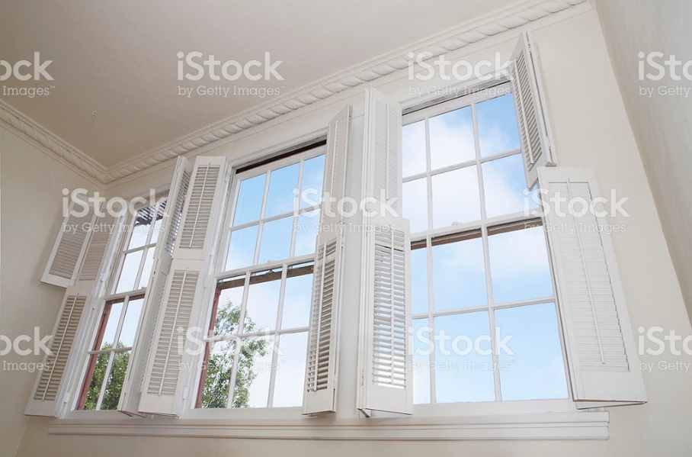

### Plantation (California)

Plantation shutters also known as California shutters are seen everywhere today and are an easy care, bold look that suit many styles of décor. They operate with a rail in the middle of the shutter that allows them to open and close the slats offering a varying level of privacy and light control. Some companies also offer a hidden operating rail on the slats. Plantation shutters can be made from wood, vinyl or a combination of the two that all have varying recommended uses and pricing.

**NOTE:** Be aware that shutters can reduce the amount of light coming into a room by up to 30% when the slats are open.

Plantation shutters can be made to fit any shape window any shape window including arched Palladian, diagonal etc. but may not be able to open in odd shapes.

**Measuring/ordering:**

* When measuring for shutters, you would take the same kind of measuring process as for all windows, however it is always best to have the company making them do the measuring for either inside or outside mount as there are many factors to consider for a successful end result.
* For example if on an inside mount there is a difference in measurement on the window by more than ½” they must be outside mounted with a frame.
* There are certain clearance levels as well for window hardware, door handles etc. that only a shutter installer will be aware of prior to ordering.
* If you are using these shutters for assignments during this course, state the window measurements (inside and outside measures) and state that the installer will do final calculations. You will state if your shutter is to be single opening, double opening,

Bi-fold or double hung.

Istock id: 483818875

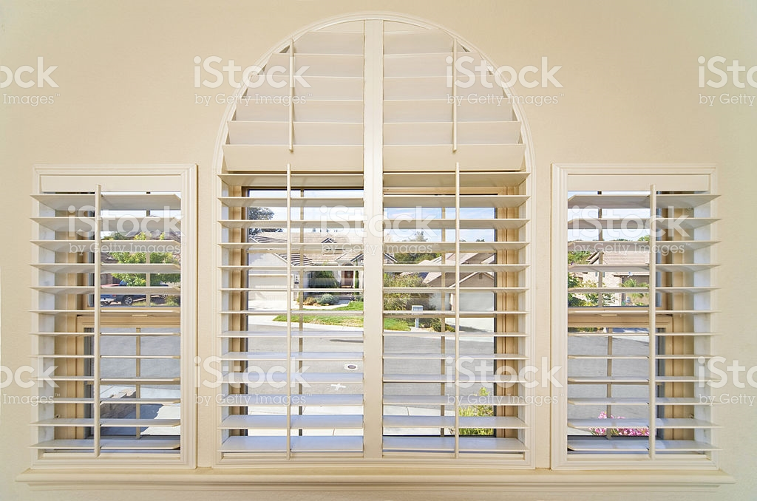

This is an interesting video explaining different styles of shutters…

<https://www.youtube.com/watch?v=Rx3bZLxo-Zs>

### Sliding panels

Sliding panels are increasing in popularity and are panels that slide like a shower door over a window or patio door. They can be made from Woven wood, California shutters and even sheer fabrics and operate on a sliding track. They offer a very modern look and are more attractive than the commercial looking old style vertical blinds.

This website shows examples of sliding panels…

<https://www.hunterdouglas.ca/vertical-blinds/skyline>

## Top treatments:

Top treatments featured this week are the hard kind made from wood or metal and are not as common to use but can be an interesting addition to a window treatment. Top treatments using soft fabrics are called valances which will be covered in next week’s lesson.

Hard top treatments are not generally used on their own but with drapery or blinds. They add an architectural feature to a window and can be upholstered in a soft fabric or made from wood that can be stained or painted to suit the décor of the room. In some cases metal can also be used to create them as well.

In your text page 482 you can see drawing examples of a Cornice, Lambrequin and Cantonniere.

### Cornice

A cornice is like a valance covering the top of the window. It can be made in numerous shapes or square and mostly made from wood that is painted or stained. A cornice can act as a feature to draw the eye upward to the top of the window. It is made to cover the top of the treatment hardware and sticks out from the wall about 4-6” allowing the treatment underneath to operate smoothly. See text page 482.

### Lambrequin

A lambrequin is much like a cornice, however the sides come partway down the sides of the window. These can be made from wood or even metal and painted or stained. They project out from the wall about 4-6” to allow the treatment underneath to operate smoothly. See text page 482.

### Cantonniere

A Cantonniere is a structure surrounding the top and sides of a window frame and extending to the floor. They are flush to the wall creating a shape around the window and can be made from wood or metal and painted or stained. This style is not often used yet can create an interesting theme or frame and would look good with a hard treatment as an inside mount on the window.

See text page 482.

### Specialty window requirements:

**Measuring unequal widths on a window:**

An example of this is having a large window in a room that has a wider middle window and 2 windows that are narrower on each side. This is a straight window would require 3 windows on one headrail.

* Measure the overall width of the entire window for both inside and outside measures.
* For inside mount use the narrowest measurement
* For outside mount calculate at 1 ½” past the frame on each side of the total width
* Then measure where you want the desired split. Often this is shown on the divided mullion on the window and you would make the split in the middle of that vertical trim.
* You need to measure each window and record on your working copy.
* All the 3 window sizes must equal the total width of the window.
* Do NOT calculate the space between the blinds as that is automatically done by the manufacturer
* You must specify the number of blinds on one headrail when ordering. You would deduct the outer 1/8” on each end blind to allow the blind to operate without rubbing on the frame for an inside mount or add 1 ½” past on each side for an outside mount.
* You would measure the length the same as for all blinds with longest measure for inside mount and 1 ½” below the frame for outside mount.

The benefit of placing blinds as 2 or 3 on one headrail is it allows each blind section to be operated as desired.

**French doors:**

French doors need some considerations taken into account when applying blinds or shutters. Since there is not a lot of frame allowance around a French door and has a handle you need to make sure the treatment you select will fit. You will need 2 to 3 ½” to mount brackets above the window. You can also add hold-down brackets 2” below the window to keep the blind in place when opening and closing to the outside. The blind will need to fall just inside the latch or slip between the handle and the door to allow free access to operate the handle. When in doubt of the fit for the treatment you are using, get a check measure from your installer before you order the treatment.

**Window cranks:**

Many windows operate open and closing with a window crank. You will need to measure the blind to allow it to hang in front of the crank and so add about 1” length for a slight bulge. It is recommended that the client change the crank to one that can fold and not project as far.

**Patio door measuring:**

Patio door blinds are very practical to use to provide privacy and light control.

* When measuring the area as with all windows, measure in 3 locations both vertically and horizontally.
* Add 1-2” past the frame on each side for an outside mounting the widest measure.
* When calculating the total length take into account t top of the headrail height to the floor and round down to the closest 1/8” so that the blind does not drag on the floor.
* This means that the blind should stack above the frame about 3” to allow for the stack up.
* If making the patio door ceiling to floor, deduct ½” for proper clearance at the floor level.

I like to order patio door blinds as 2 on the same headrail to allow ½ to be opened and the other to remain down with the slats open but. The same measurements would apply for the total width and length of the treatment and the manufacturer would make sure the split between the two would allow for ease of operation. You would give the total measurements as instructed above and state 2 on one head rail.

**Corner windows:**

A corner window is when 2 windows on right angled walls meet in the corner. Corner windows can be tricky for blinds to allow both to operate without touching the other and appear neat together. To do this one blind must bypass in front of the other. The drawings shows how one will but up to the corner of the window and the other will bypass on an inside mount. You can also do the same with an outside mount

By Linda Guthro.

The vertical box is the bypass that runs the full width of the window and the horizontal is the butt that stops just 1/8” shy of the first box.

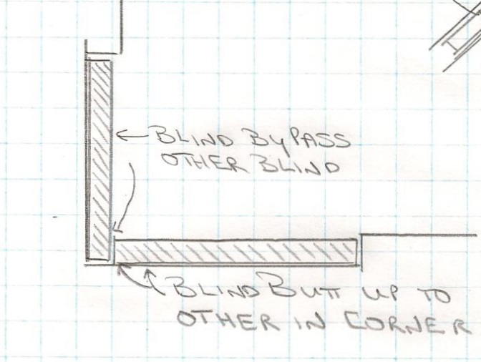

**Bay windows:**

Bay windows are not all able to accommodate 2” depth blinds depending on the recess allowance and the angle of the bay. It is best to get a check measure before ordering to make sure what you want to do is possible as you need to leave room for each blind to operate inside the bay. It is best to make a template showing detailed angles and measurements that allow each blind to operate unencumbered. I always get a check measure for this kind of window and the installer will measure accurately. I can still quote overall sizing needed for each blind.

By Linda Guthro

Notice how A+B as well as C+D are angled to allow each blind to operate in this window. The flat middle window can be one or two blinds as desired and you would measure the length you want for that window.

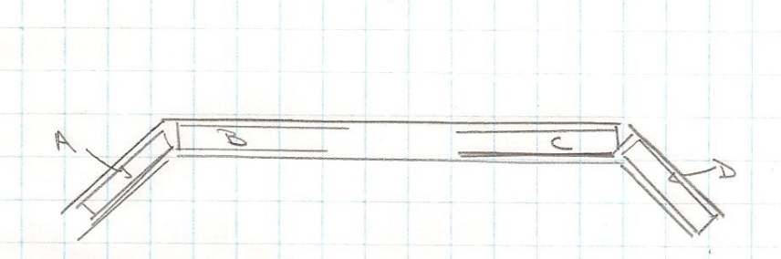

**Cutouts:**

Cutouts are sometimes needed in a blind to have and area removed to avoid obstructions like window air conditioners. It is usually from a corner or a bottom on a blind. Not all manufacturers allow cut-outs so make sure to check with them before you plan this treatment.

Measure the blind size as you would normally and then measure the area that needs to be cut-out.

Provide a drawing for the manufacturer with all measures showing on the drawing for clarity along with your order form. Cutouts are rarely needed, however it is important to know about if you happen upon this request.

By Linda Guthro

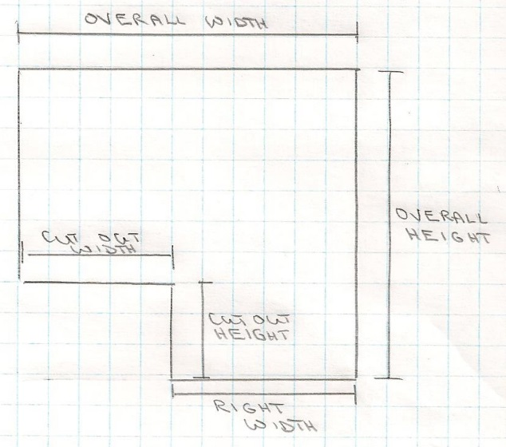

**Template needs:**

Sometimes you will come across an unusual window that the client wants covered. Arches, circles, Quarter circles are architectural in nature and not meant to be covered.

Rarely are arched windows perfectly proportioned and not a perfect semi-circle.

A perfect semi-circle would be if the width is 60” then the height would be 30”.

Since most are not perfect and if you do have this request it must be planned with a template as it is the only way to get an exact fit.

**Steps to make a template:**

* Tape butcher paper or brown wrapping paper over the window opening. The paper must be strong enough to withstand the handling in the window.
* Allow plenty of overlap and use paper that has never been folded or creased
* Draw the exact outline of the window by tracing over the inside edge of the window frame.
* If using an outside mount blind add the desired amount past the frame and draw a second outline around it for the size of the finished shade.
* Add all measurements on the template to send to the manufacturer.

By Linda Guthro

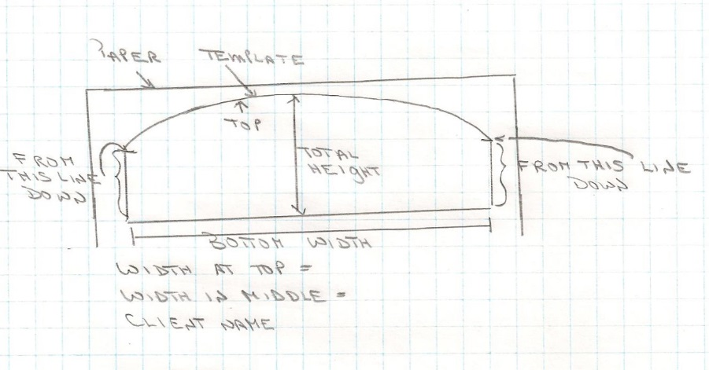

## Practice examples:

**Inside mount blind question:**

Window width 36” by length 48” recessed by 2 ½”

Trim around outside of glass measure = 3”

Ceiling height 9’

Glass 18” from ceiling

Draw a working copy in ½” scale on graph paper

Calculate the size of an inside mount wood blind with 2” wide slats

What side do you want the operating cord to be?

**Inside mount Answer:** Can we reveal this answer once the student tries the question?

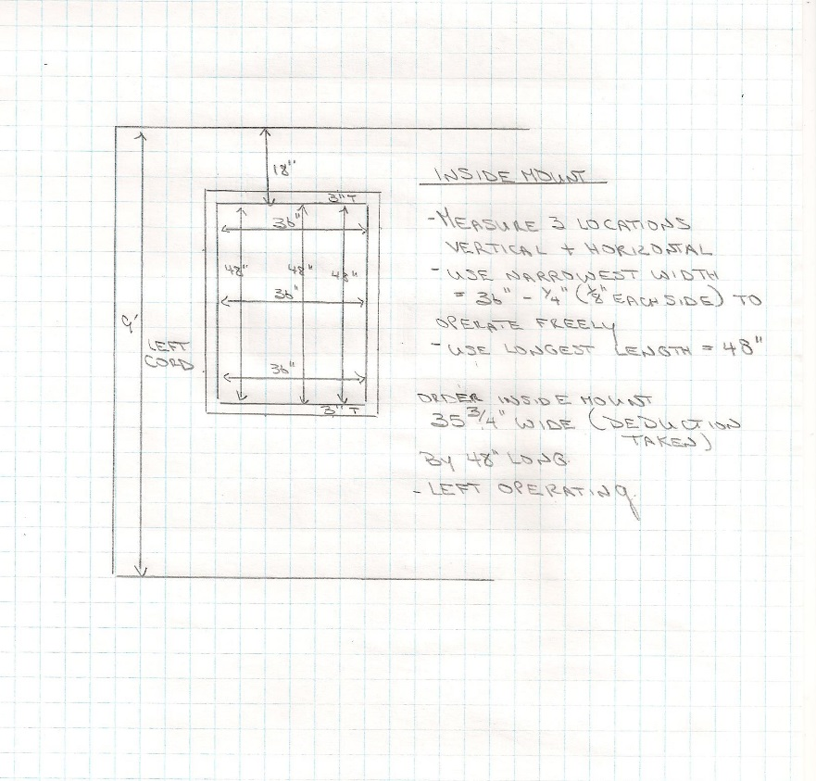

**Outside mount blind question:**

Window width 36” by length 48”

Trim around outside of glass measure = 3”

Ceiling height 9’

Glass 18” from ceiling

Draw a working copy in ½” scale on graph paper

Calculate the size of an outside mount wood blind with 2” wide slats

What side do you want the operating cord to be?

**Outside mount Answer:** Can we reveal this answer once the student tries the question?

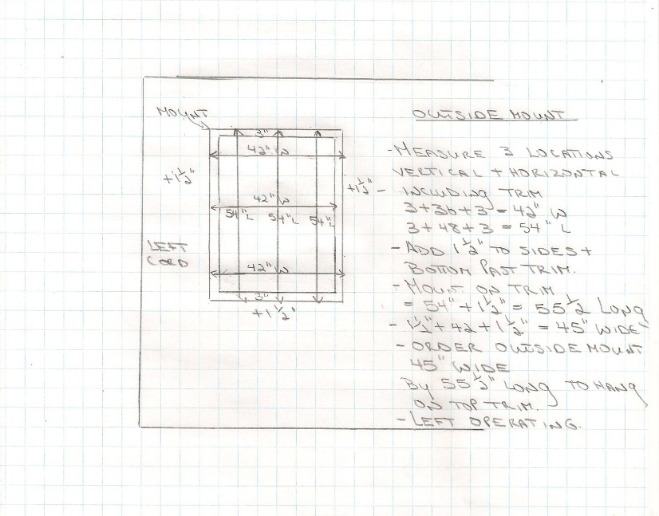

## Conclusion:

As you can see from this lesson, there is an amazing amount of choice for hard treatments on today’s market. How lucky we are to have such as huge selection and variety to choose from. Measuring needs to be exact, however overall they are easier to calculate that soft treatments. I encourage you to visit stores that sell blinds and shutters to see what is on the market.

I have included some manufacturers here for you to investigate.

All blinds can be used on their own or with soft treatments for a layered effect. You will be amazed at all they have to offer and how you can make your windows unique to your home!

There are several hard treatment manufacturers in Canada and I have listed some here for you to look at on their websites.

1. Canadian Blind Manufacturing Inc.

<http://www.cdnblind.com/>

2. Shade-O-Matic

[www.shade-o-matic.com/](http://www.shade-o-matic.com/)

3. Levolor

<https://www.levolor.ca/>

4. Hunter Douglas

<https://www.hunterdouglas.ca/>

********************* End of instructional content *************************